
Department | FED
Subject | DSA-2
Academic Year | Ⅰ-Ⅲ Semester(2025-26)
Faculty Name | Ms. Alluri Swathi
Student Name | Karnati Laxmi Lahari
Roll Number | 2520090206
Branch | CSIT
Course Outcome | 3

Case Study Topic: SportsAnalytics – Athlete Performance & Tournament Management System using DFS
Work Done Summary:
Implemented Depth First Search (DFS) in Java to manage athlete connections, team structures, and tournament traversal operations. Athletes and teams were represented using graphs where each player is a node and matches/team relationships are edges. DFS traversal was used to explore connected players, analyze team formations, and track tournament paths efficiently. Implemented recursive DFS traversal to visit all connected athlete nodes and display player performance flow. Compared DFS traversal with normal traversal methods and observed efficient graph exploration for sports analytics systems.

Implementation Details :
- Created Graph class using adjacency list representation.
- Added athlete/player nodes and team connections using addEdge().
- Implemented DFS traversal using recursion and visited[] array.
- DFS explored all connected players in tournament/team networks.
- Main method demonstrated player insertion, team connections, and DFS traversal.
- DFS efficiently analyzed tournament paths and team connectivity.

Result : Screenshots/Output
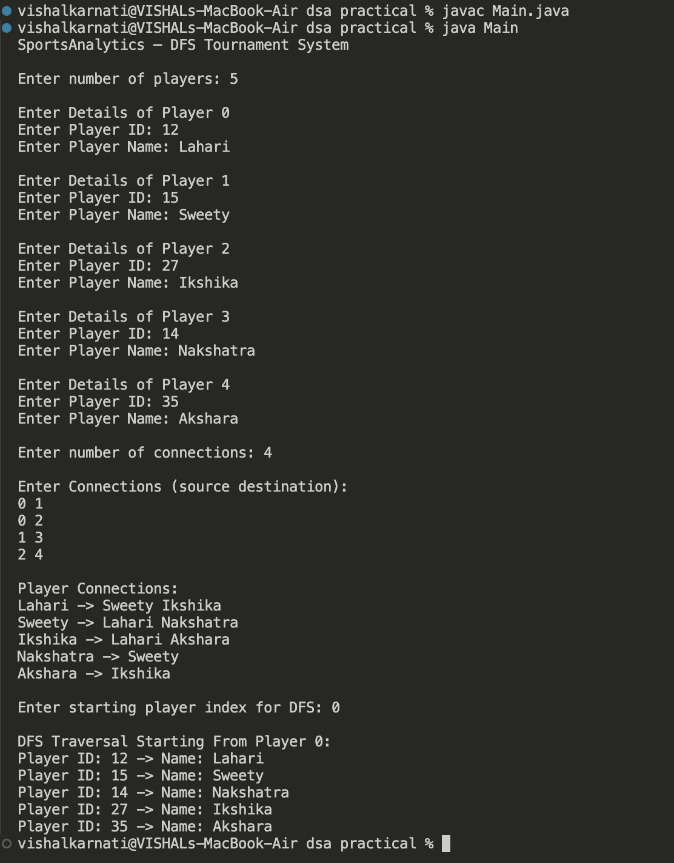Time Complexity:
- DFS Traversal: O(V + E)
where:
  - V = Number of Players (Vertices)
  - E = Number of Connections (Edges)
DFS efficiently explores tournament/player networks and is highly useful for:
- Team connectivity analysis
- Tournament bracket traversal
- Match relationship tracking
- Player network exploration
Compared to repeated manual traversal methods, DFS provides systematic and faster graph exploration.

GitHub Link :
Student Signature | Faculty Signature

